Effective Interest Rate Calculator

# Store Listing

## Title

Effective Interest Rate Calculator

## Short Description

Effective Interest Rate Calculator. A simple app designed to do just that.

## Full Description

Effective Interest Rate Calculator

This app is designed to calculate effective interest rates and nothing else. It is hopefully the first in a series of apps I intend to make with each app performing a single mathematical task. The idea is that a user downloads the app, performs the calculation they wish to perform and then uninstall the app. The free version contains ads.

Find the source code on GitHub!

<https://github.com/Blunderchips/Effective-Interest-Rate-Calculator>

<https://www.youtube.com/watch?v=s8yuGVhRtQk>

The icon used can be found on game-icons.net

(<http://game-icons.net/delapouite/gui/chart.html>)

# Screenshots

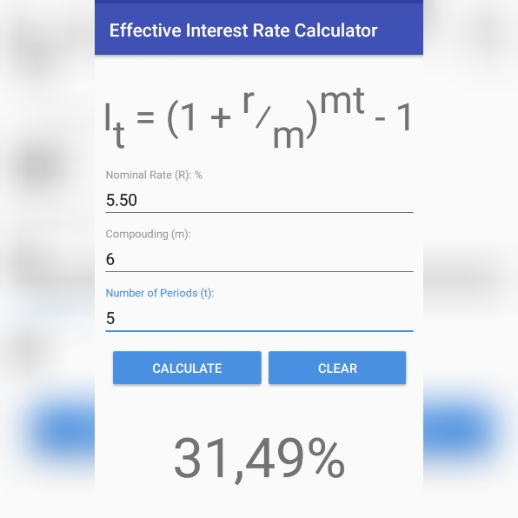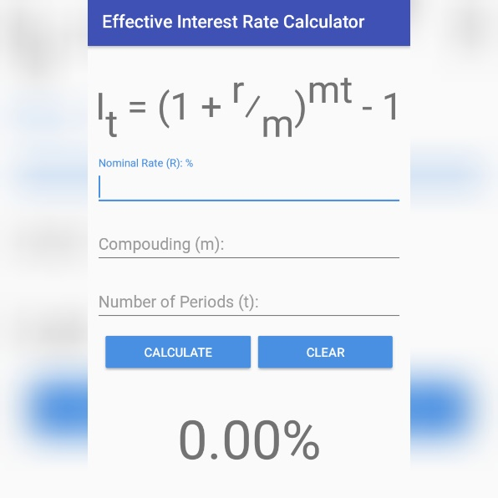

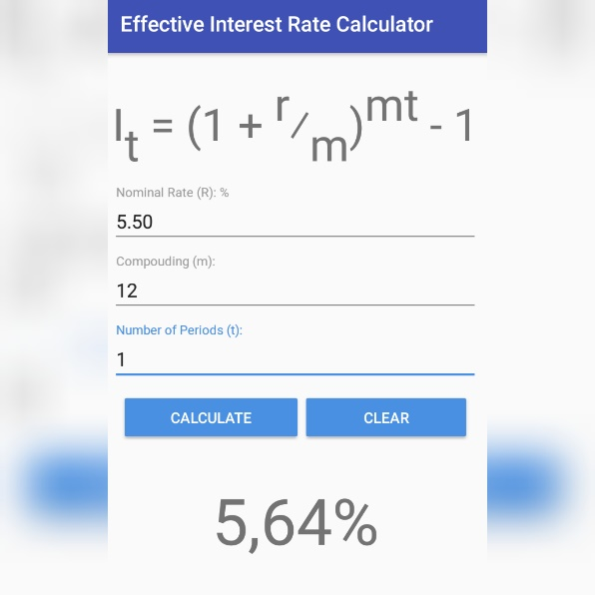

# Icon

